Chemical Record Keeping for CLAG Mosquito Management Programs

This fact sheet outlines chemical record keeping requirements for local governments participating in the Contiguous Local Authorities Group (CLAG) funding program. It includes minimum data requirements and a record keeping template that can be adapted for use.

Introduction
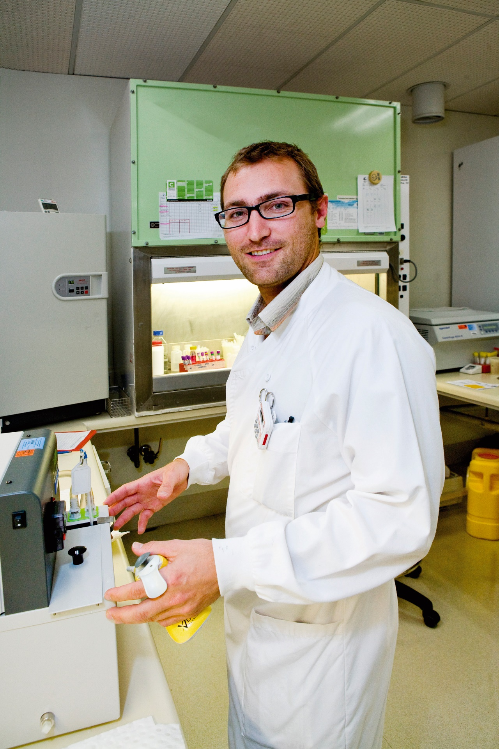
Chemical pesticides are a key component of local government integrated mosquito management programs in Western Australia. Pesticide application aims to reduce mosquito populations and mitigate the public health risks associated with mosquitoes, particularly the incidence of mosquito-borne diseases.

CLAG Requirements
The CLAG funding program, administered by the Department of Health (the Department), provides funding to CLAG member local governments for mosquito control chemicals. To be eligible for this funding, local governments must provide the following information to support their annual funding request:
- Financial acquittal of chemical expenditure from the previous financial year
- Chemical treatment records for the previous financial year
These commitments are detailed in each CLAG’s Memorandum of Understanding with the Department and are necessary to meet public sector compliance requirements and maintain the integrity of the CLAG funding program.
Classification: Official

Chemical Record Keeping Requirements
To maintain eligibility for CLAG funding, local governments must document the following information for mosquito control chemical treatments and make it available to the Department when requested.
  - Date and time of chemical treatment
  - Name of applicator
  - Method of application (e.g. backpack sprayer, helicopter, drone)
  - Location of treatment (described in sufficient detail to be readily identified e.g. drainage basin Smith Reserve, Eaton)
  - Product trade name (e.g. VectoPrime FG, Prolink briquets)
  - Quantity and application rate of product (use standard units such as weight, volume, or number. Informal measures such as “½ bag” or “handful” should not be used)
  - Size of area treated (expressed in m² or hectares)

A chemical record keeping template is provided in Appendix 1. Local governments can adapt the template to suit their needs. Opening the document in Excel (right click the table > Object > Open) will enable drop-down functionality for easier data entry.
Local governments should also be aware of record keeping obligations for mosquito control chemicals under the following legislation:

- Biosecurity and Agricultural Management Act 2007
- Biosecurity and Agricultural Management (Agricultural Chemical Record Keeping) Regulations 2020
- Biosecurity and Agricultural Management (Aerial Application) Regulations 2018
The Department of Primary Industries and Regional Development administers this legislation and can be contacted for further information.

Further information
Medical Entomology
E: medical.entomology@health.wa.gov.au
T: (08) 9285 5500

APPENDIX 1 CHEMICAL TREATMENT RECORD TEMPLATE

